HOLY SATURDAY
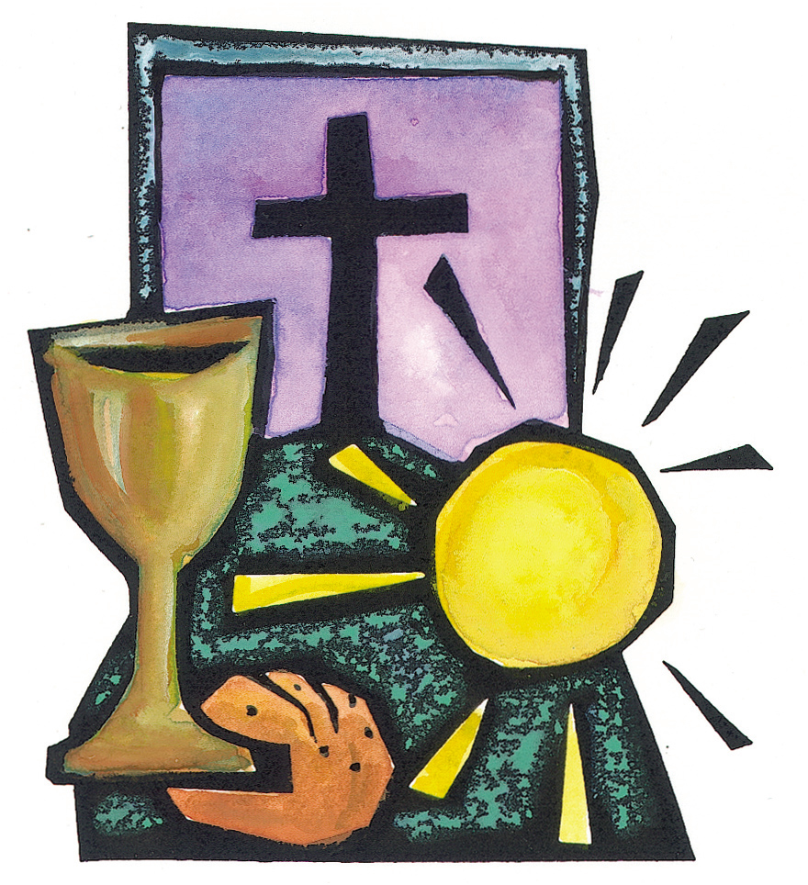
AND
EASTER SUNDAY

Having completed our Lenten observance and after the liturgies of Holy Thursday and Good Friday we are now at the stage of celebrating the Easter Vigil and the day of resurrection that is Easter Sunday. Holy Saturday is about emptiness, ‘The cross is empty now Jesus lies in the tomb and everything around us is still.’ The heavens and the earth cry out with longing for the sinless one who is not to be found, if we stop to think for a moment we remember that Jesus died and rose again on the third day. We wait, as mourners beside a grave, unsettled, ill at ease, almost not knowing what to do with ourselves. The Church has only one thing to do today: to pray through the emptiness of Holy Saturday. Holy Saturday then is the day when we experience watching and waiting at the tomb as we await the celebration of the Resurrection which we celebrate in the Easter Vigil and the season of Easter. The Psalm for Easter Sunday says, “This is the day the Lord has made; let us rejoice and be glad in it.”Above all days, Easter is a day of joy .

But what is joy? The answer St. Francis gave to this question is famous. St. Francis said to his Brother Leo, "When we come to St. Mary of the Angels [our house], soaked by the rain and frozen by the cold, all soiled with mud and suffering from hunger, and we ring at the gate of the place and the brother porter comes and says angrily: 'Who are you?' And we say: 'We are two of your brothers.' And … he does not open for us, but makes us stand outside in the snow and rain, cold and hungry, until night falls—then if we endure all those insults and cruel rebuffs patiently, … oh, Brother Leo, … perfect joy is there!”¹
Whatever we may think of St. Francis’s explanation of perfect joy, Easter reminds us that Francis’s kind of joy is not the end of the story. At Easter, we celebrate the other kind of joy, the kind each of us longs for, when every tear is wiped away, and there is no sorrow anymore—no more suffering from weather or hunger or hurtful human beings. As we sing in the much-loved hymn by Fr. John Foley, S. J., at Easter, “the cross and passion past, dark night is done, bright morning come at last!”² When we ourselves rise to meet our risen Lord, in that bright morning we will hear him say, “Come away, beloved. The winter is past; the rain is gone, and the flowers return to the earth” (Song of Songs 2:10-12). In the loving union of that encounter, all the heartbrokenness of our lives will be redeemed. That will be perfect joy.

This is the ‘day which the Lord has made.’ Alleluia! Take fresh hope, brothers and sisters of the whole world! With Christ our Passover everything is possible! Christ goes forward in our future!” Let us go forward together as Easter people

